# ACKNOWLEDGEMENT

I have taken efforts in this project. However, it would not have been possible without the kind support and help of many individuals and organization. I would like to extend my sincere thanks to all of them.

I am highly indebted to **DIGIPODIUM INSTITUTE** for their guidance and constant supervision as well as for providing necessary information regarding the project & also for their support in completing the project.

I would like to express my gratitude towards my friends & member of **DIGIPODIUM** for their kind co-operation and encouragement which help me in completion of this project.

I would like to express my special gratitude and thanks to group members for giving me such attention and time.

My thanks and appreciations also go to my colleague in developing the project and people who have willingly helped me out with their abilities.

# DECLARATION

I **ANJANI SONI** hereby declare that this project report entitled **PERSONAL GYM TRAINER USING AI** submitted by me, under the guidance of **Mr. ZAID KAMIL** of **Digipodium Institute, Lucknow** is my own and has not been submitted to any other University or Institute or published earlier.

#### Signature of Student:

#### ANJANI SONI

**MCA VIth Semester Date: 6th June,2022**

**ABSTRACT**

"Health is wealth!" For hundreds of decades, we have known this saying. But only 20-30% of the globe truly has healthy habits and, other than walking, the rest of the 70% have no physical exercise. Indeed, adults are not fitness-related and early in life acquire health problems. However, individuals have turned to their health and wellbeing during the past several months. It is, of course, because of the coronavirus COVID-19!

Our lives get busier, and we barely have time to practice on a regular basis. It is even more difficult to maintain a healthy diet! Then, a lot of confused issues arise: which diet works best? What plan is to be chosen? These all appear a bit scary. But nothing to worry about; [artificial intelligence](https://www.analyticssteps.com/blogs/what-artificial-intelligence-types-uses-and-how-it-works) is here to assist!

Yes, AI revolutionizes fitness through fitness equipment that makes home workouts smarter and better. In addition to the smart wearable ([Apple](https://www.analyticssteps.com/blogs/how-apple-uses-ai-and-big-data) Watch, Fitbit, and more), which may help you track your fitness, personal AI trainers are also gaining in popularity at an unparalleled rate.

Those who use AI personal trainers would know this new notion in the field of fitness, but those who are amateur must be intrigued about it.

# TABLE OF CONTENTS

|  |  |  |
| --- | --- | --- |
| **Serial No.** | **Contents** | **Page No.** |
| **1.** | **Introduction** | **1** |
| **2.** | **System Analysis**   * Identification of need * Preliminary investigation * Feasibility study * Software development life cycle * Project scheduling * Software requirement specifications * UML diagrams | **3**  **4**  **5-7**  **8-9**  **10-11**  **12-20**  **21-24** |
| **3.** | **System Design**   * Modules contribution by student * Modules description | **25-27**  **28-30** |
| **4.** | **Testing**   * Client/Server side testing * Types of testing used | **31-32**  **33-35** |
| **5.** | **Sample Layouts**  - Screenshots | **36-51** |
| **6.** | **Future Scope** | **52** |

|  |  |  |
| --- | --- | --- |
| **7.** | **Conclusion** | **53** |
| **8.** | **Challenges And Limitations** | **54** |
| **9.** | **Bibliography** | **55** |
| **10.** | **Glossary** | **56** |

**PERSONAL GYM TRAINER**

## INTRODUCTION

**Artificial intelligence is a computer machinery which help in guiding in many ways like AI based heavy material, and AI based personal gym trainer. We all are here to brief on the topic AI based trainer and gyming plays a major role to make our life healthy-wealthy and wise .**

**As you all know there severe pandemic situation like COVID-19 arrive in the whole universe which pushed up the AI based technology, by which the people get easily there personal gym trainer, posture correctness, and many activities in one line or in one slot.**

# IDENTIFICATION OF NEED

#### OBJECTIVE

* **Motion Processing Engine – Accurately detects and analyzes human motion and skeletal position during home fitness workout**.
* **Neural Network Algorithm – Clone specific trainer motion to provide accurate representation of specific movements of goals**.
* **Adaptive Workouts- Analyzes real-time performance to adjust exercise difficulty and provide optimal solution.**

#### SCOPE

* **It helps to decrease the stress and decrease depression remotely.**
* **AI has enabled post-workout analysis and assessment ,allowing users to qualify their improvement ,leading to habits.**
* **Gamifying the workout experience by measuring activity is a way to increase engagement and incentivize gym goers to work out regularly, either in gyms or remotely.**

#### These are a few of many pros this writing software has to offer:

* + Real-time detection and correction of errors.
  + Highly accurate outputs.
  + Simple to use for all age group.

**PRILIMINARY INVESTIGATION**

We have investigated that several related AI Workout Apps are available in the market but they are either paid or free to only some extend. Not single software is present in the market which is providing all the features given by our web application for free. Our app first investigation is to identify the posture then after rule and regulate the exercise in a freely ways.

#### Some issues come on the way of our app that is :-

* + - Knowing about it is the major concern various people don’t know about this app.
    - App function are to be perform easily without any server or network issue.
    - Basic knowledge regarding to the app is given before through the mass media.
    - Hence apart from this all the concerns get correct through the various means like for speed reduce the apk size.

# FEASIBILITY STUDY

While developing the project we were keeping feasibility in our mind. And now our project supports all the types of feasibility. Now we can better understand about the feasibility study given below.

The feasibility report of the project holds the advantages and flexibility of the project. This is divided into three sections:-

* + Economic Feasibility
  + Technical Feasibility
  + Behavioral Feasibility
  + Operational Feasibility

#### Economic Feasibility:-

Economic analysis is the most frequently used method for evaluating the effectiveness of the candidate system. More commonly known as cost/benefit analysis, the procedure is to be determining the benefits and savings that are expected from a candidate and compare them with costs. If benefits outweigh costs, then the decision is made to design and implement the system. This project is economically feasible as it does not require any additional hardware and software.

A systems financial benefit must exceed the cost of developing that system.

i.e. a new system being developed should be a good investment for the organization. Economic feasibility considers the following:

1. The cost to conduct a full system investigation.
2. The cost of hardware and software for the class of application.
3. The benefits in the form of reduced cost or fewer costly errors.

#### Technical Feasibility:-

Technical feasibility centers on the existing computer system (Hardware and Software etc.) and to what extend it support the proposed addition. In this project, all the necessary cautions have been taken care to make it technically feasible. Using a key the display of text/object is very fast. Also, the tools, operating system and programming language used in this localization process is compatible with the existing one. The technical needs of the system vary considerably but might include:-

1. The facility to produce outputs in a given time.
2. Response time under certain conditions.

The project is technical feasible because of the availability of the required software hardware and technology. The changes can be made be made in the system as and when required.

#### Behavioral Feasibility:-

People are inherently resistant to change, and computers have been known to facilitate change. An estimate should be made of how strong a reaction the user staff is likely to have toward the development of a computerized system. Therefore it is understandable that the introduction of a candidate system requires special efforts to educate and train the staff. The software that is being developed is user friendly and easy to learn. In this way, the developed software is truly efficient and can work on any circumstances, tradition, locales. Behavioral study strives on ensuring that the equilibrium of the organization and status quo in the organization neither are nor disturbed and changes are readily accepted by the users. Thus these factors are considered for a Behavioral feasibility study:-

1. Need analysis
2. Provide the user information pertaining to the preceding requirement.

#### Operational Feasibility:-

It determines how acceptable the software is within the organization. The evaluations must then determine the general attitude and skills. Such restriction of the job will be acceptable. To the users are enough to run the proposed budget, hence the system is supposed to the feasible regarding all except of feasibility. In operational Feasibility, we attempt to ensure that every user can access the system easily.

Operational feasibility of the project also exists because in today’s world most

of the people are using the internet and are purchasing the products online. There is nothing complex in the system that cannot be used by people. It is socially accessible feasible as well because of its usefulness and easiness in getting information. Time feasibility also exists because it can be developed and implemented in the given time. As far as legal feasibility is concerned there is no such restriction faced by the system.

**SOFTWARE DEVELOPMENT LIFE CYCLE**

**Spiral Model** is one of the most important Software Development Life Cycle models, which provides support for **Risk Handling**. In its diagrammatic representation, it looks like a spiral with many loops. The exact number of loops of the spiral is unknown and can vary from project to project. **Each loop of the spiral is called a Phase of the software development process.** The exact number of phases needed to develop the product can be varied by the project manager depending upon the project risks.

As the project manager dynamically determines the number of phases, so the project manager has an important role to develop a product using spiral model.

We have also used spiral model in our project to ensure budget and time constraints which is very important while developing the project. By using this model are able to make this project on time without any delay.

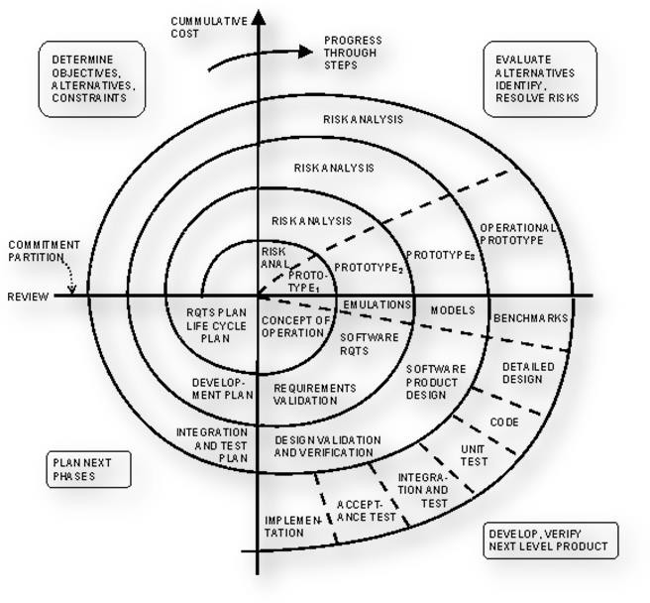

#### Fig- Spiral Model

**PROJECT SCHEDULE PLAN**

The objective of Software Planning is to provide a framework that enables the manager to make reasonable estimates of resources, cost, and schedule. These estimates are made within a limited time frame at the beginning of a software project and should be updated regularly as the project progresses. In addition, estimates should attempt to define best case and worst case scenario so that project outcomes can be bounded.

#### Gantt chart:

A Gantt chart is a popular type of chart that illustrates a project schedule. Gantt Chart illustrates the start and finish dates of the terminal elements and summary elements of a project. Terminal element and summary comprise the work breakdown structure of the project.

Gantt chart of our PERSONAL GYM TRAINER is given below:



|  |  |  |  |  |  |  |  |  |
| --- | --- | --- | --- | --- | --- | --- | --- | --- |
| Task | 25 Jan-25 Feb | 25 feb-7 Mar | 8Mar- 10Apr | | 11Apr- 14May | | 15May- 19May | 20May-25May |
| Develop project proposal | 31 days |  |  | |  | |  |  |
| Analysis |  | 10 days |  | |  | |  |  |
| Designing |  |  |  | |  | |  |  |
|  |  |
| 30 days | |
| Coding |  |  |  | |  |  |  |  |
| 34days |  |
| Unit Testing |  |  |  | |  | | 5 days |  |
| Implementation |  |  |  | |  | |  | 5 days |

# SOFTWARE REQUIREMENT SPECIFICATION

## Functional Requirements:

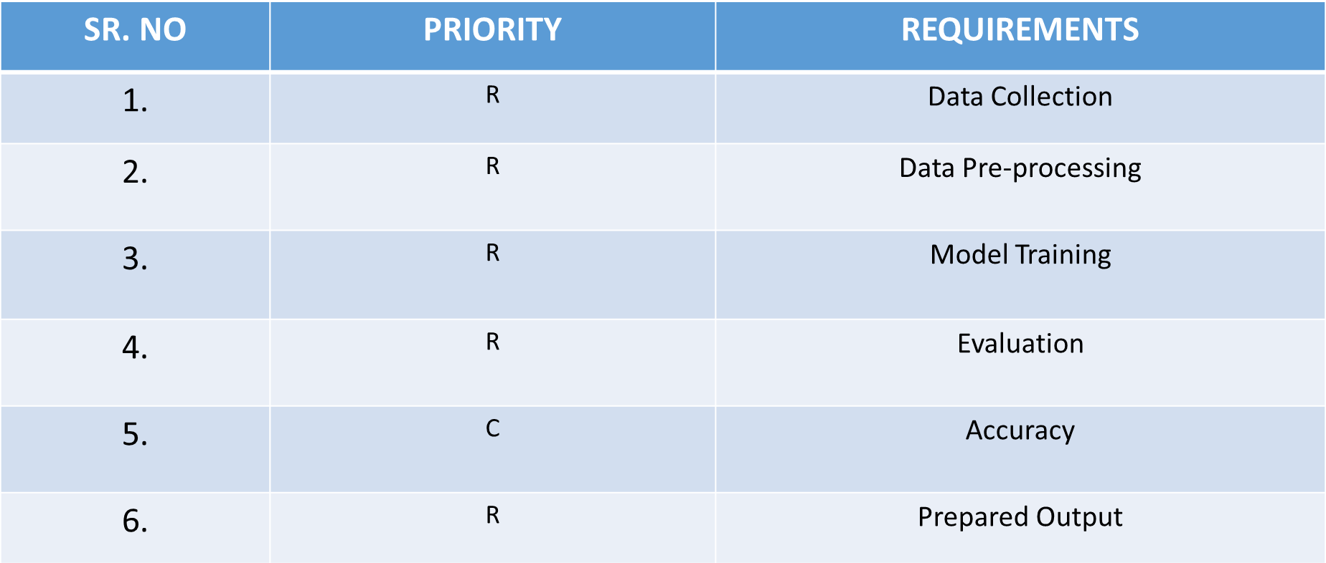

**WHERE R=> REQUIRED; C=> CONDITIONALLY REQUIRED; O=>OPTIONAL**

## Non-Functional Requirements:

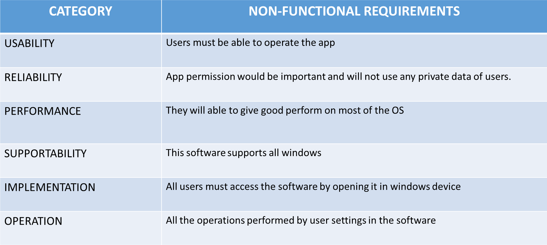

**Hardware Requirement**

**Client Side**

Processor : Dual Core or above

RAM : 2 GB

Disk space : 6GB

Monitor : 15’’or above

Others : Keyboard, mouse, Internet Connection

**Server Side**

Processor : Dual Core or above

RAM : 2 GB

Disk space : 2GB

Monitor : 15’’or above

Others : Keyboard, mouse, Internet Connection

**SOFTWARE REQUIREMENTS**

* 1. **Client Side:**

#### Web Browser (Google Chrome,Firefox,IE9 or above)

* 1. **Server Side:**
* **Window 7 or above**
* **Visual Studio Code**
* **Python 3.7 or above**
* **Streamlit**

**DOCUMENT CONVENTION**

* **Font Family**

Garamond

#### Font Size

Heading – 22

Sub-Heading –16 (Bold & Underlined) Paragraph – 16

#### Font Color

Content-black

* **Text Align** Heading – Center Paragraph – left

# SOME OTHER TOOLS USED IN PROJECT

## Operating system:

The operating system used is windows 10.The software can also run on Windows 7,8,10 and 11 as well.

## Python:

Python is **a programming language with objects, modules, threads, and automatic memory management**. Its benefits are quite well-known. It is simple and easy to use, portable, extensible, built-in structure, and also, it is open-source.

It is an interpreter, high-level, general-purpose programming language. Created by Guido Van Rossum and first released in 1991, Python has a design philosophy that emphasizes code readability, notably using significant whitespace. It provides constructs that enable clear programming on both small and large scales.

# Streamlit:

Streamlit is **an open source app framework in Python language**. It helps us create web apps for data science and machine learning in a short time. It is compatible with major Python libraries such as scikit-learn, Keras, PyTorch, SymPy(latex), NumPy, pandas, Matplotlib etc.

## Sqlalchemy:

SQLAlchemy considers the database to be a relational algebra engine, not just

a collection of tables. Rows can be selected from not only tables but also joins

and other select statements; any of these units can be composed into a larger structure. SQLAlchemy's expression language builds on this concept from its core.

## NumPy:

NumPy is a library for the Python programming language, adding support for large, multi-dimensional arrays and matrices, along with a large collection of high-level mathematical functions to operate on these arrays.

## Open CV:

**OpenCV** is the huge open-source library for the computer vision, machine learning, and image processing and now it plays a major role in real-time operation which is very important in today’s systems. By using it, one can process images and videos to identify objects, faces, or even handwriting of a human.

## Mediapipe:

## MediaPipe is a Framework for building machine learning pipelines for processing time-series data like video, audio, etc. This cross-platform Framework works in Desktop/Server, Android, iOS, and embedded devices like Raspberry Pi and Jetson Nano.

## 

## 

## Sqlite:

**SQL is a query language** and is very popular in databases. Many websites use MySQL. SQLite is a “light” version that works over syntax very much similar to SQL. SQLite is a self-contained, high-reliability, embedded, full-featured, public-domain, SQL database engine. It is the most used database engine on the world wide web.

.

# USER CHARACTERISTICS

**DEVELOPER**

A developer uses this SRS to maintain and modify this application.

**CLIENT**

The client uses this SRS to verify the pre- defined requirement.

They can also suggest some further requirements in future as per according to their need.

**TESTER**

A tester performs Black Box or White Box Testing according to pre-defined requisites provided in SRS.

**ANALYST**

Uses this document for system testing and they use it for analysis of the proposed system as required by the client.

# UML DIAGRAMS

**ACTIVITY DIAGRAM**

**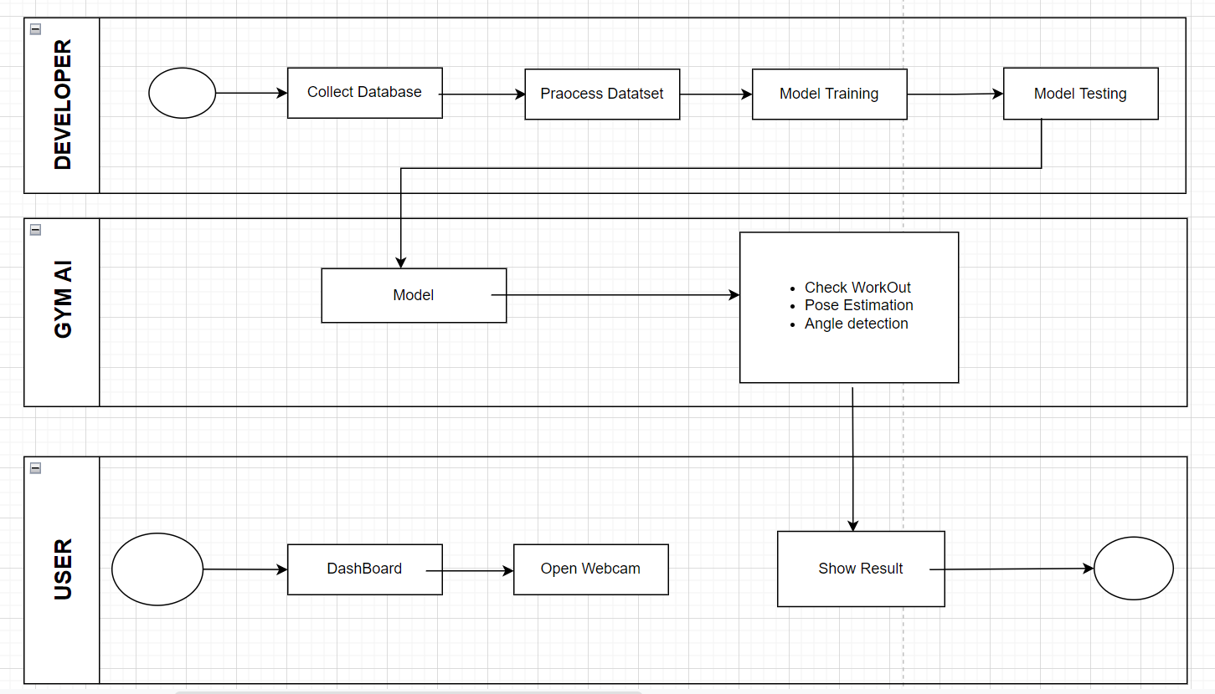**

**USE CASE DIAGRAM**

**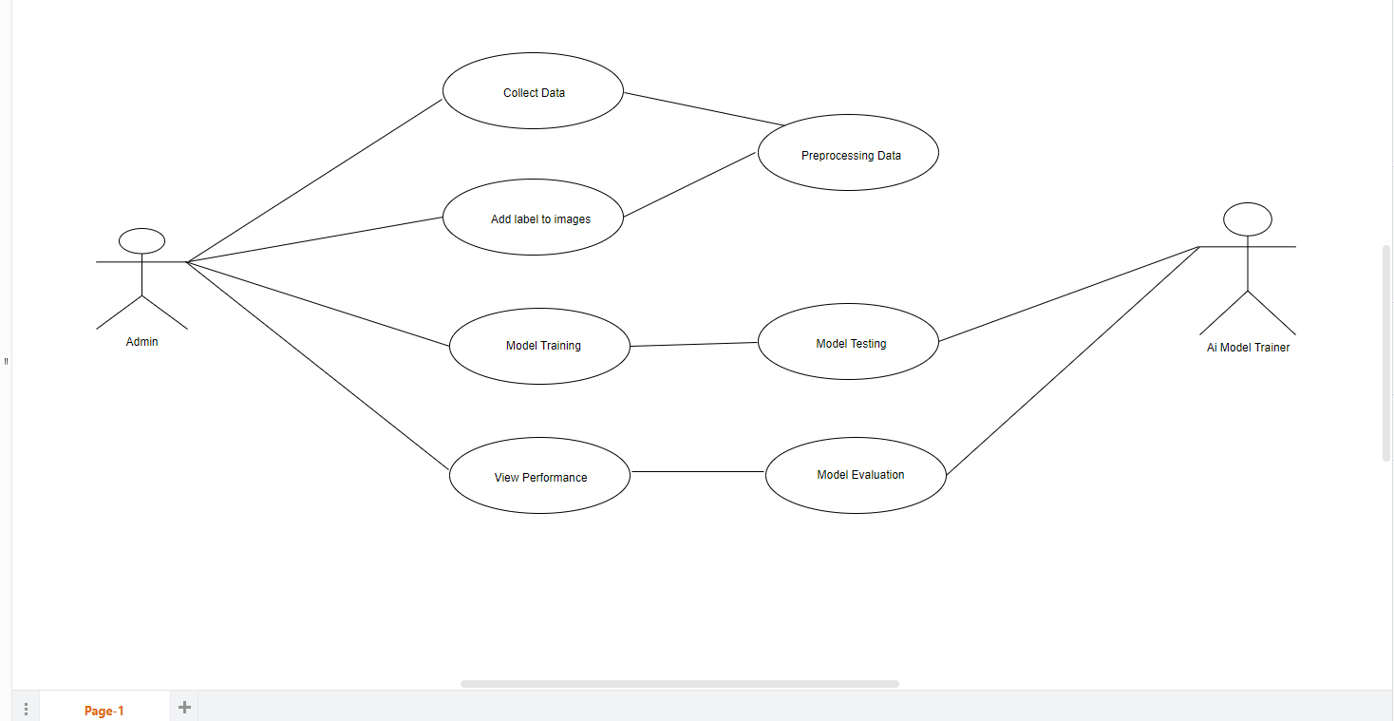**

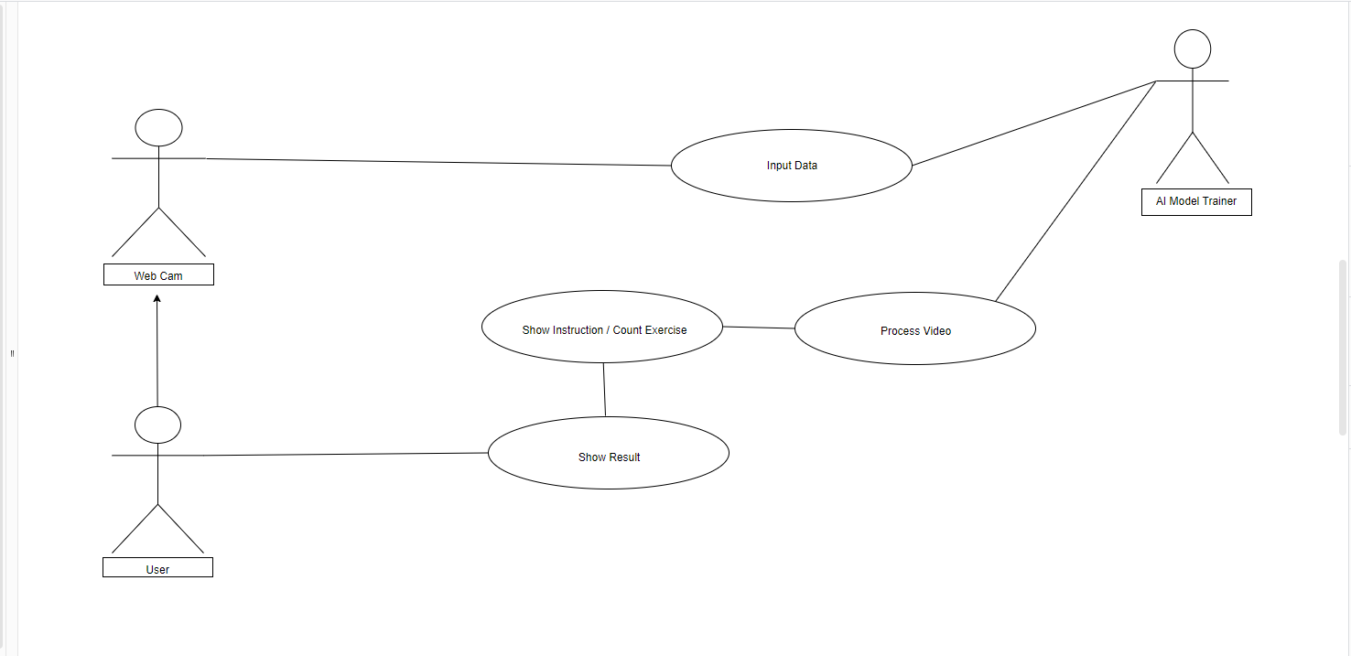

**SYSTEM DESIGN**

**MODULES CONTRIBUTION BY STUDENTS**

#### Gym Exercise (DATABASE)

#### Angle Detection

1. **Workout System**
2. **Webcam Stream Manager**
3. **Pose Estimation**
4. **Image Extraction System**
5. **Data Dashboard System**
6. **User Workout Visualization**
7. **Repetition Counter**
8. **Motion Processing System**

**In this project, two members are involved and so, we have divided the whole project into two groups:-**

**The following modules are handled by Aishwarya Singh :-**

* + **Module 1** – Gym Exercise (DataBase)
  + **Module 2** – Angle Detection
  + **Module 3** – Workout System
  + **Module 4** – Webcam Stream Manager
  + **Module 5 -** Pose Estimation

**The following modules are handled by Anjani Soni :-**

* + **Module 6** – Image Extraction System
  + **Module 7** – Data Dashboard System
  + **Module 8** – User Workout Visualization
  + **Module 9** – Repetition Counter
  + **Module 10** – Motion Processing System

# MODULES DESCRIPTION

## Gym Exercise (DATABASE):

Collection of data.

In this module Trainers need maximum efficiency when managing clients and creating programs and workout plans for their clients. Before the development of fitness technology that assists in increasing the efficacy of trainers, it was all pen and paper and data tracking programs on computer discs.

## Angle Detection:

Open CV is a cross-platform, open-source, real-time computer vision library. It’s a C++ library with Java and Python wrappers and has algorithms that can detect human features, identify objects, classify human actions in videos, track objects, follow eye movements, recognize scenery, and much more.It works in real-time, and as an added bonus it already has built-in trained models to detect people..

## Workout System:

* a practice or exercise to test or improve one's fitness for athletic competition, ability, or performance.
* a test of one's ability, capacity, stamina, or suitability.
* an undertaking or plan intended to resolve a problem of indebtedness especially in lieu of bankruptcy or foreclosure proceedings.

## Webcam Stream Manager:

Formal Text Transformer is just the inverse of casual transformer because it is providing all the functions of it. The only change is that if you enter the formal text summary then it will convert that into the casual text.

## Pose Estimation:

Again this is also a subset of text transformer which transforms the text written in active voice into passive voice. Active voice is basically a combination of Subject+Verb+Object, while converting the active into passive subject and object will be interchanging their position and the state of verb will also be change. This can be done easily with the help of a library present in a python 3.7 or above known as transformer which takes these words as tokens.

# 6. Image Extraction System:

**Image extraction means the real image extract with the formal image which displayed on the screen.**

Image extraction system aims to provide an overview of the process in a system that converts the image of a document into text so that it is easier to use (save, manage or search for information) or representing in interesting visualization.

## 7. Data Dashboard System:

**All the things include or come in a single stick is known as**

**data dashboard system.**

A data dashboard is a tool businesses use to help track, analyze, and

display data, usually to gain deeper insight into the overall wellbeing of

the organization, a department, or even a specific process.

## 8. User Workout Visualization:

This visualization involves using your senses to create a mental image of a physical task before you attempt it, including imagining what the movement will feel like in your muscles and your mind.

## 9. Repetition Counter:

Reps is short for repetitions, or the number of times that you perform

any given exercise in your workout. If a fitness instructor or an

online [training plan](https://www.livestrong.com/article/13719761-race-running-training-plans/) tells you to do 10 reps of a [body-weight squat](https://www.livestrong.com/article/211859-how-to-do-air-squats/),

that means you'll repeat the exercise 10 times.

Each rep of an exercise puts your muscles through several

positions, including a lengthening phase, a contraction phase and

a shortening phase, according to the [American Council on Exercise](https://ace-fitness.sjv.io/c/2698199/984595/12960?subId1=w_5162579&u=https%3A%2F%2Fwww.acefitness.org%2Feducation-and-resources%2Flifestyle%2Fblog%2F5867%2Fhow-many-reps-should-you-be-doing%2F&subId3=xid:fr1654252466137agd" \t "_blank) (ACE).

## 10. Motion Processing System:

**Doing activity on which motion the workout done and the process take place motion processing system.**

**Motion** is the measurement of movement around a specific joint or body part.

Each joint has its own level of flexibility, expressed in degrees.

**Flexibility** is the range of motion around a joint, and can refer to ligaments, tendons, muscles, bones, and joints

# TESTING

We have tested our project to insure that it is fully functional. In order to perform testing test cases are designed with the intent of finding the correct pose in the project and help in correct the pose. Testing begins at the module level and is conducted systematically. It is generally conducted by independent test groups or third party.

Testing is done in Personal Gym Trainer with help of black box testing that exercise all the functional requirement of the project test cases are designed using this approaches by providing set of input conditions to get the expected output.

#### Test Cases Designed

* 1. **TEST CASES FOR CLIENT**

To run this project we have to first run the app.py file in python terminal as soon as the file get compiled, the network URL will be created and the connection will be established and hence the project will start running on the default web browser of your system.

**Status:**The Project Has Been Loaded Successfully!!!

#### TEST CASES FOR SERVER

#### On loading of every model we are getting the desired result. There are many results generated for the same input according to the choice of the users.

Changes are occurring because of using the quality text polishing.

**Software testing** is an investigation conducted to provide stakeholders with information about the quality of the product or service under test. Software testing can also provide an objective, independent view of the software to allow the business to appreciate and understand the risks of software implementation. Test techniques include, but are not limited to, the process of executing a program or application with the intent of finding [software](http://en.wikipedia.org/wiki/Software_bug) [bugs](http://en.wikipedia.org/wiki/Software_bug) (errors or other defects).

Software testing can be stated as the process of validating and verifying that a software program/application/product:

1. Meets the requirements that guided its design and development.
2. Works as expected.
3. Can be implemented with the same characteristics.

# TYPES OF TESTING

We have used many types of testing while developing this project partially or completely in many phases of project. Some description of types of testings is given below:-

#### Black Box Testing

**Black-box testing** treats the software as a "black box"—without any knowledge of internal implementation. Black-box testing methods include: [equivalence partitioning](http://en.wikipedia.org/wiki/Equivalence_partitioning), [boundary value analysis](http://en.wikipedia.org/wiki/Boundary_value_analysis), [all-pairs testing](http://en.wikipedia.org/wiki/All-pairs_testing), [fuzz](http://en.wikipedia.org/wiki/Fuzz_testing) [testing](http://en.wikipedia.org/wiki/Fuzz_testing), [model-based testing](http://en.wikipedia.org/wiki/Model-based_testing), [exploratory testing](http://en.wikipedia.org/wiki/Exploratory_testing) and specification-based testing.

#### White Box Testing

**White-box testing** is when the tester has access to the internal data structures and algorithms including the code that implements these.

Types of white-box testing

The following types of white-box testing exist:

* [API](http://en.wikipedia.org/wiki/Application_programming_interface) testing (application programming interface) - testing of the application using public and private APIs.
* [Code coverage](http://en.wikipedia.org/wiki/Code_coverage) - creating tests to satisfy some criteria of code coverage (e.g., the test designer can create tests to cause all statements in the program to be executed at least once)
* [Fault injection](http://en.wikipedia.org/wiki/Fault_injection) methods - improving the coverage of a test by introducing faults to test code paths
* [Mutation testing](http://en.wikipedia.org/wiki/Mutation_testing) methods
* [Static testing](http://en.wikipedia.org/wiki/Static_testing) - All types Test coverage

#### Functional Testing

Functional testing refers to activities that verify a specific action or function of the code. These are usually found in the code requirements documentation, although some development methodologies work from use cases or user stories. Functional tests tend to answer the question of "can the user do this" or "does this particular feature work."

#### System Testing

**System testing** of software or hardware is testing conducted on a complete, integrated system to evaluate the system's compliance with its specified [requirements](http://en.wikipedia.org/wiki/Requirements). System testing falls within the scope of [black box testing](http://en.wikipedia.org/wiki/Black_box_testing), and as such, should require no knowledge of the inner design of the code or logic.

#### Various level Of Testing

Before implementation the system is tested at two levels: Level 1

Level 2

#### Level 1 Testing (Alpha Testing)

Alpha testing is simulated or actual operational testing by potential users/customers or an independent test team at the developers' site. Alpha testing is often employed for off-the-shelf software as a form of internal acceptance testing, before the software goes to beta testing.

#### Level 2 Testing (Beta testing)

Beta testing comes after alpha testing and can be considered a form of external [user acceptance testing](http://en.wikipedia.org/wiki/User_acceptance_testing). Versions of the software, known as [beta](http://en.wikipedia.org/wiki/Beta_version) [versions](http://en.wikipedia.org/wiki/Beta_version), are released to a limited audience outside of the programming team. The software is released to groups of people so that further testing can ensure the product has few faults or [bugs](http://en.wikipedia.org/wiki/Computer_bug). Sometimes, beta versions are made available to the open public to increase the [feedback](http://en.wikipedia.org/wiki/Feedback" \l "In_organizations) field to a maximal number of future users.

# SCREENSHOT

**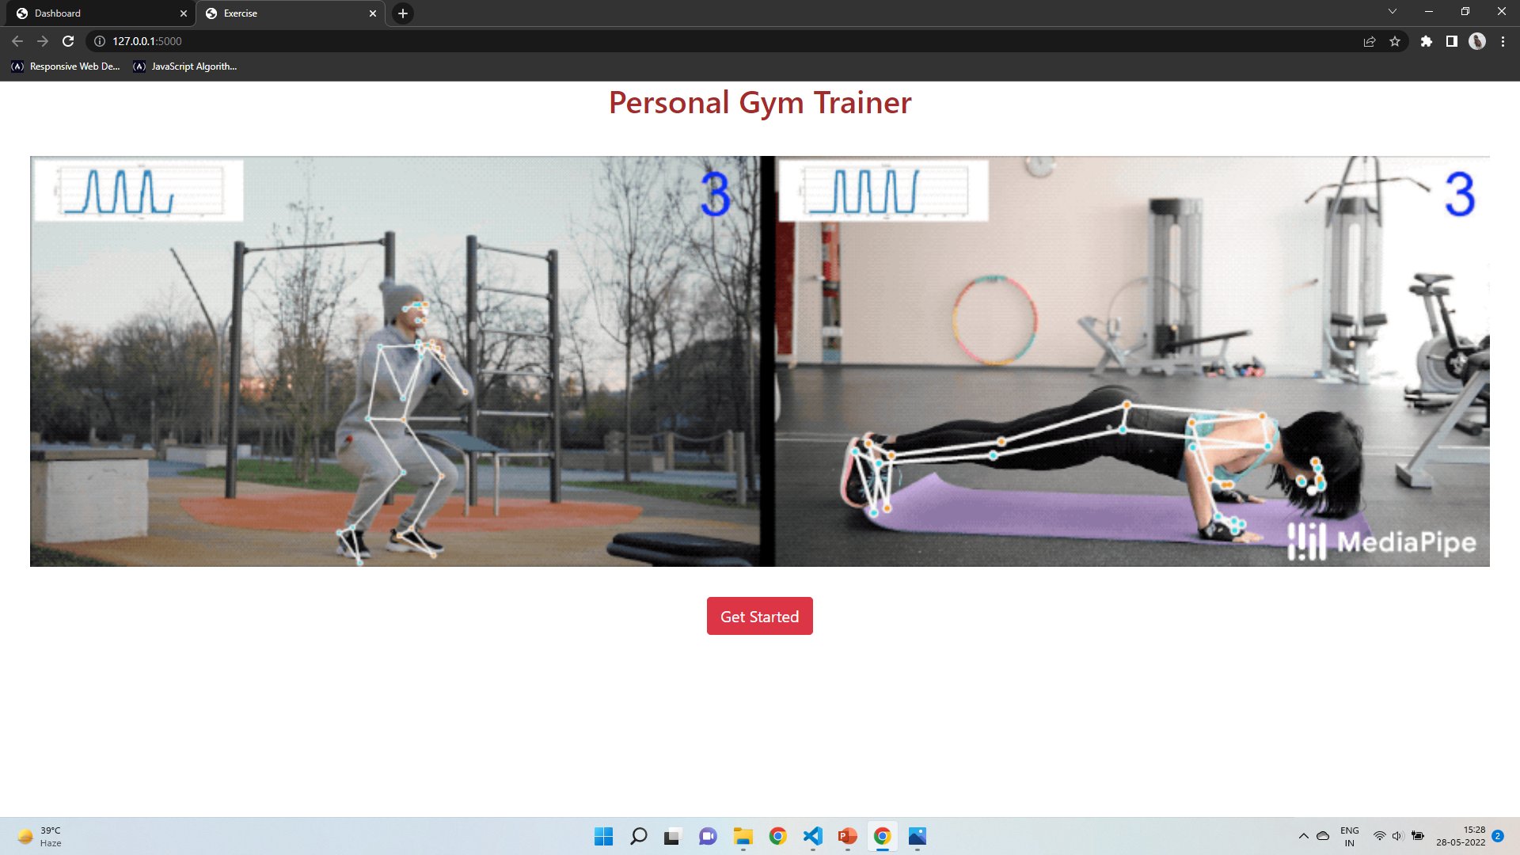**

**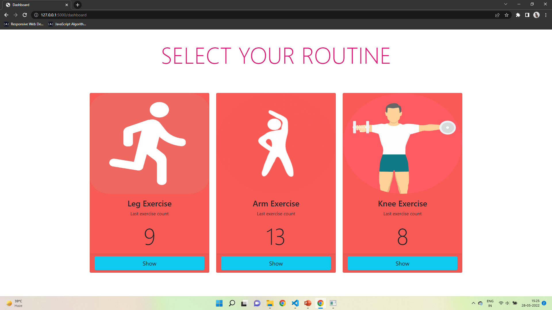**

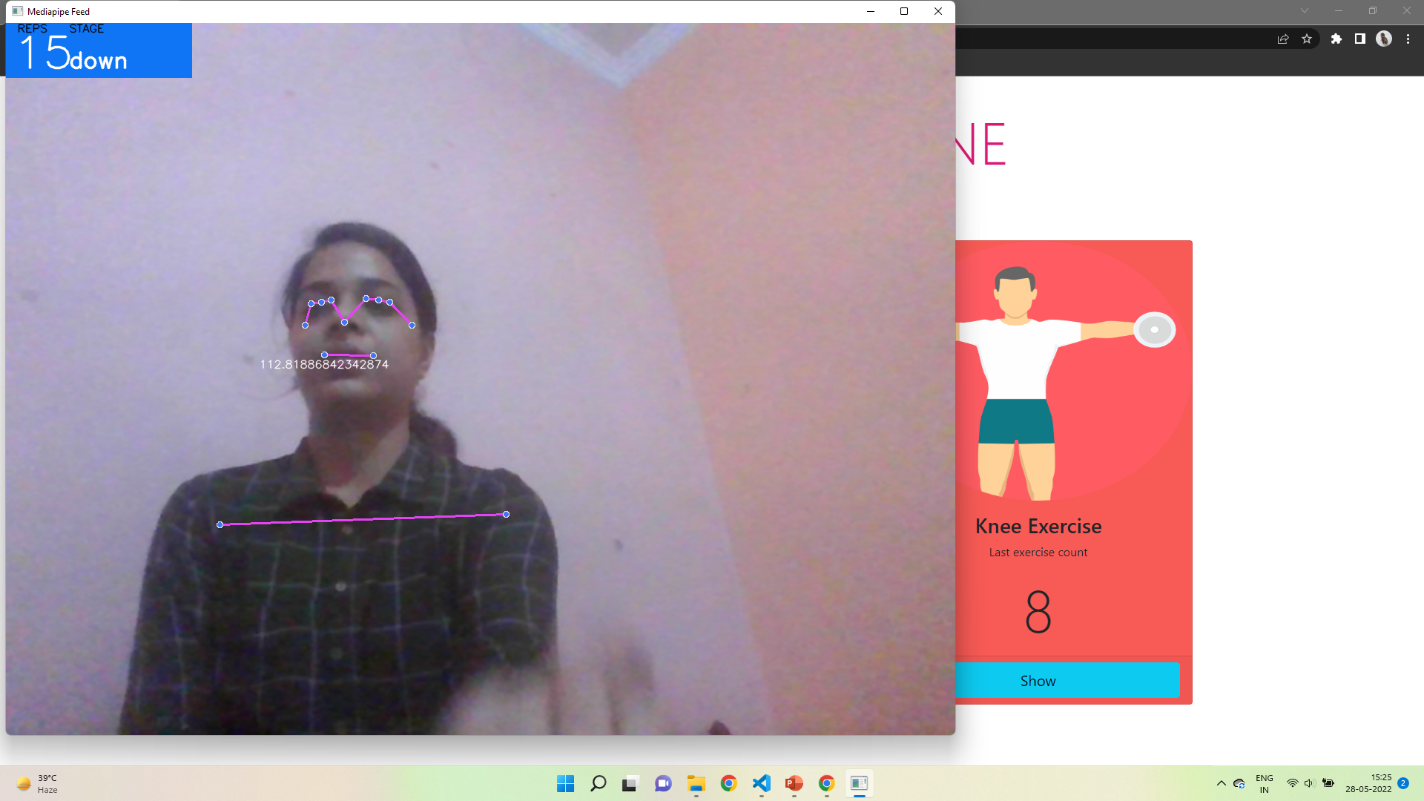

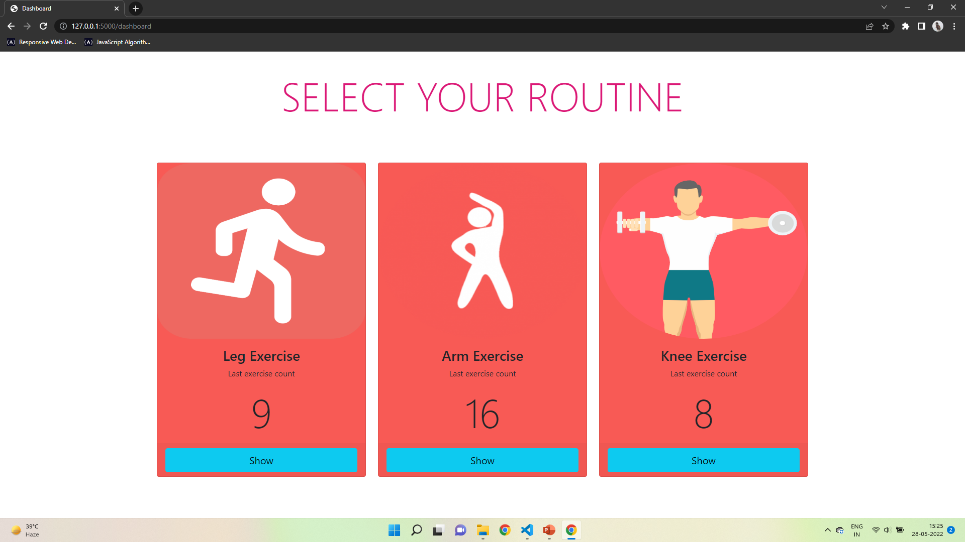



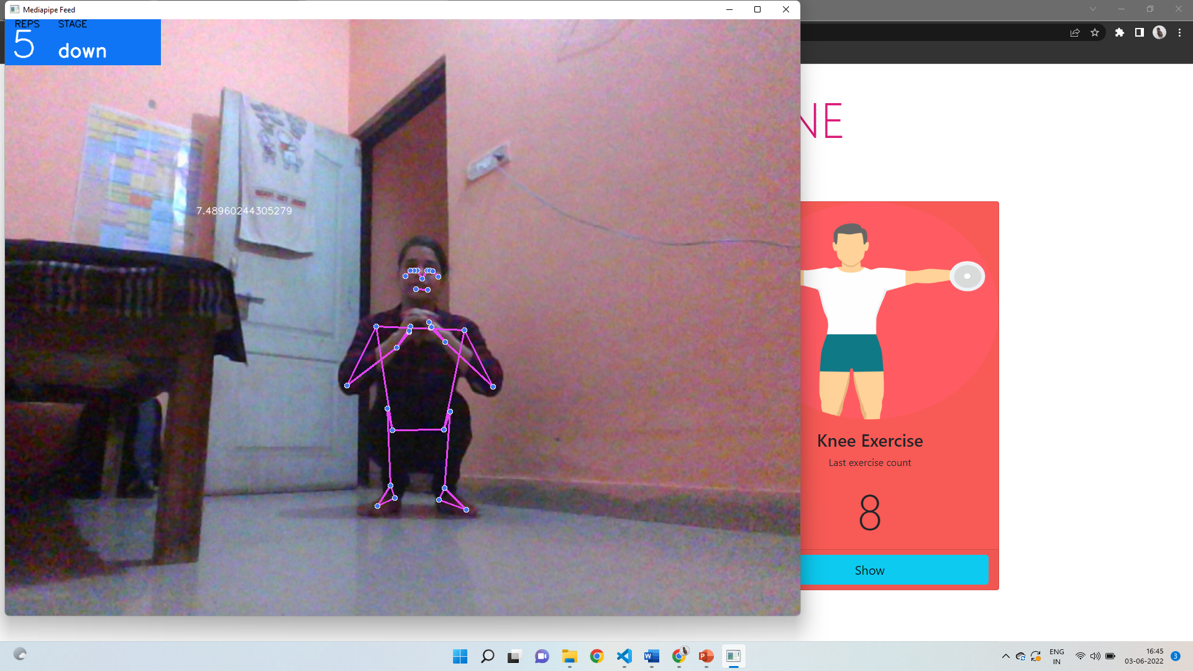

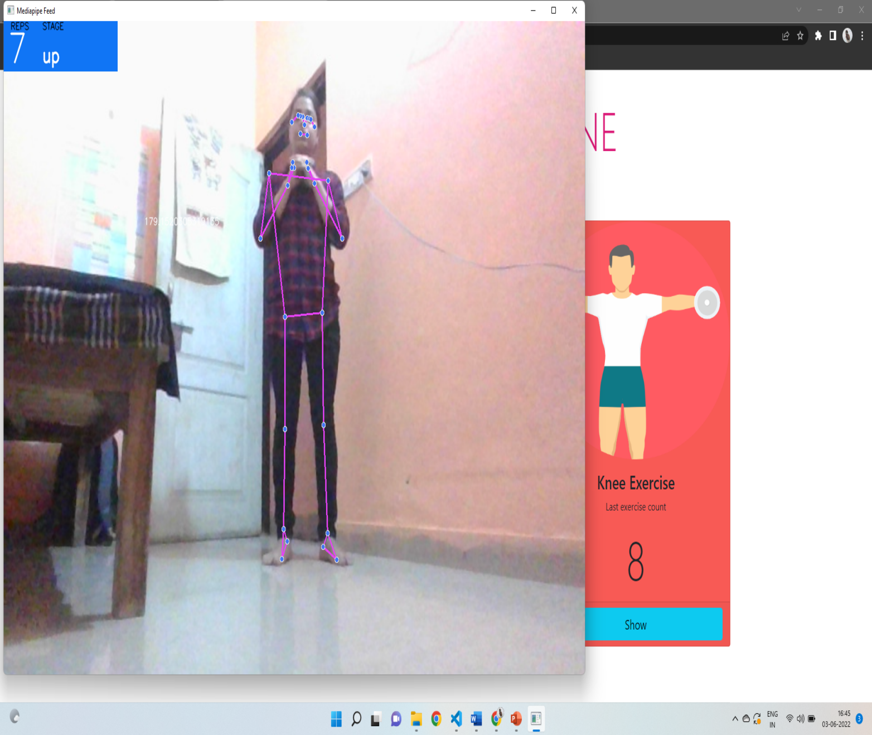

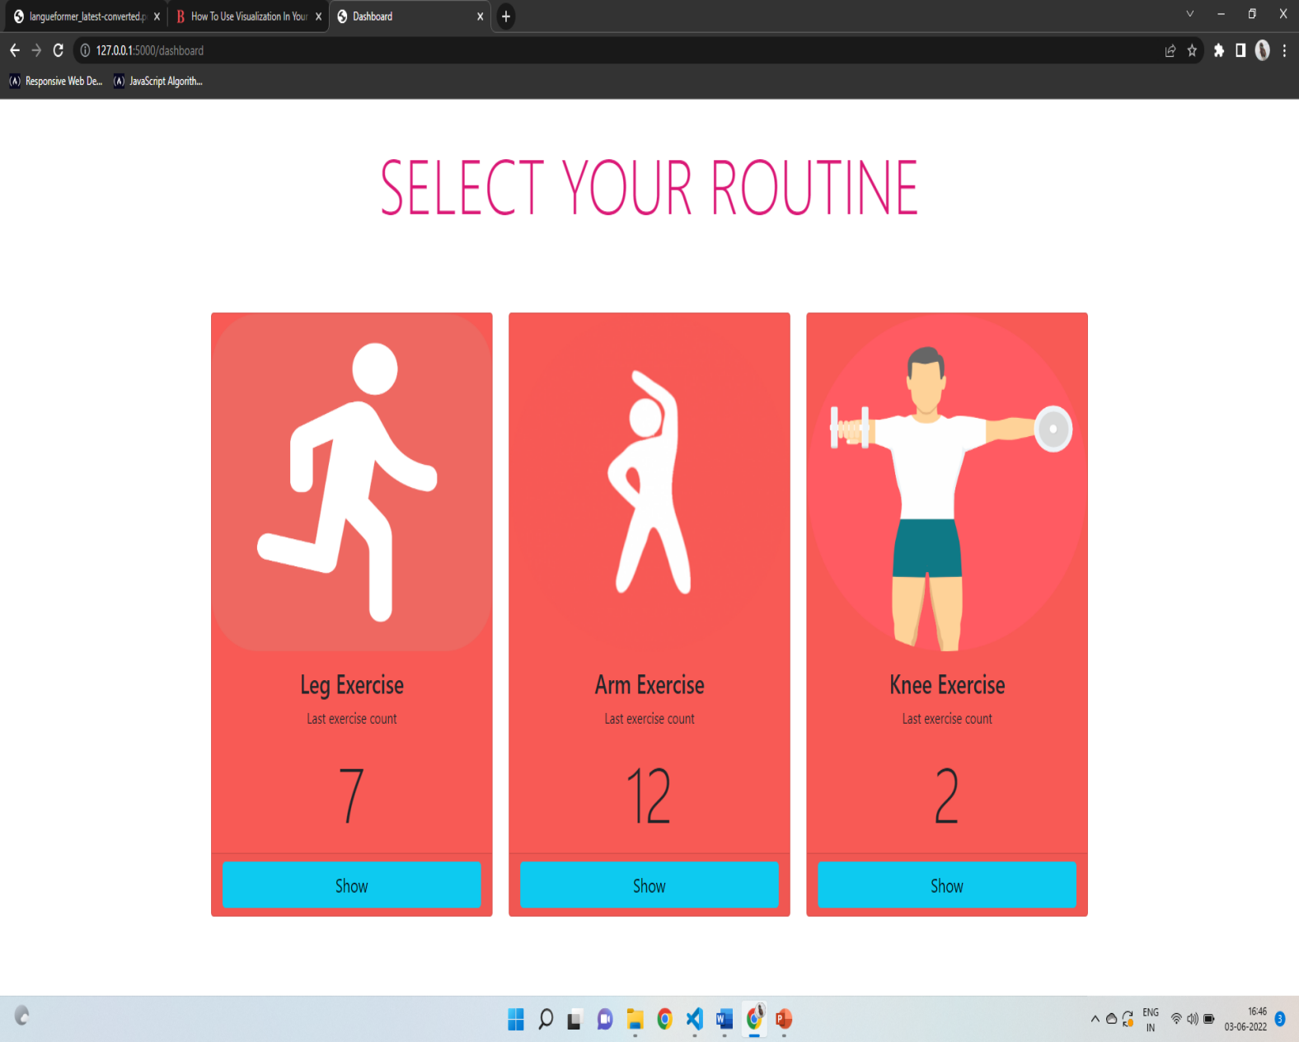

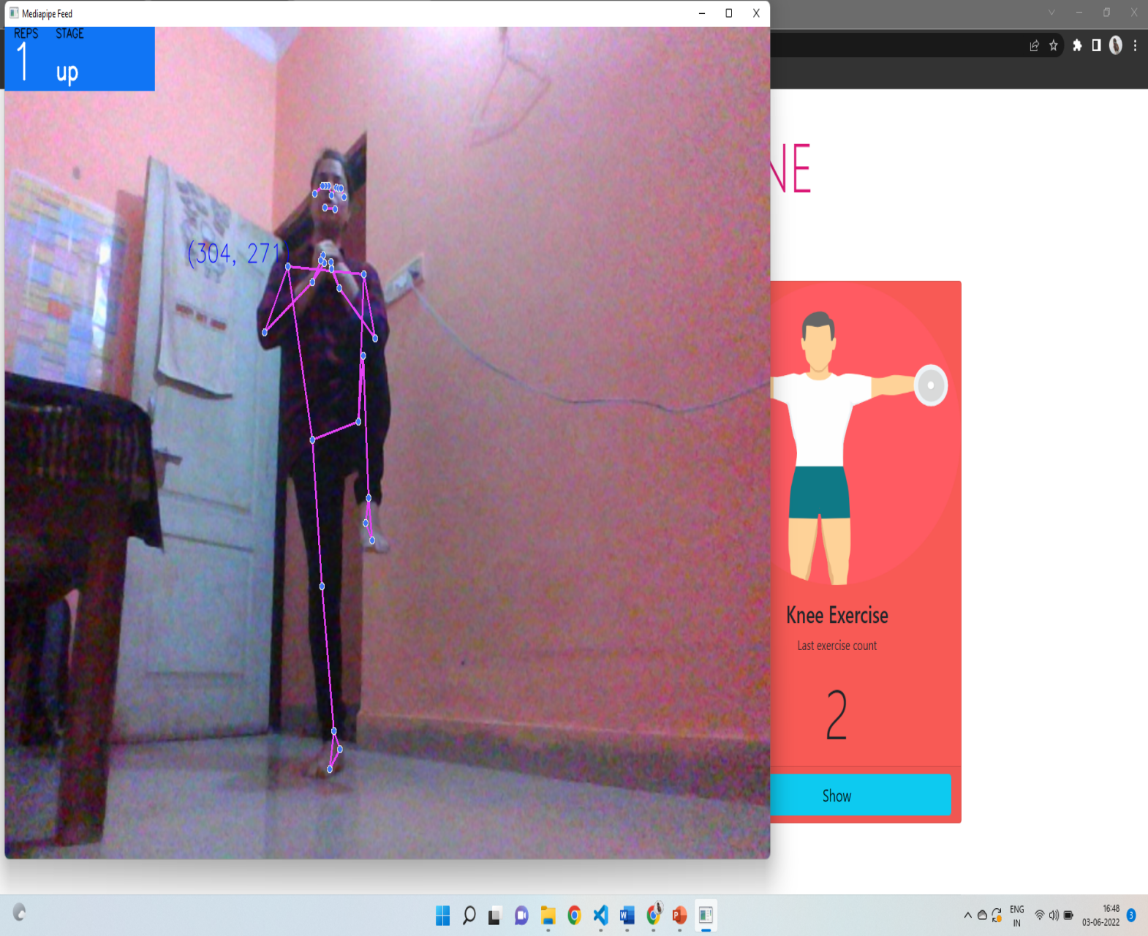

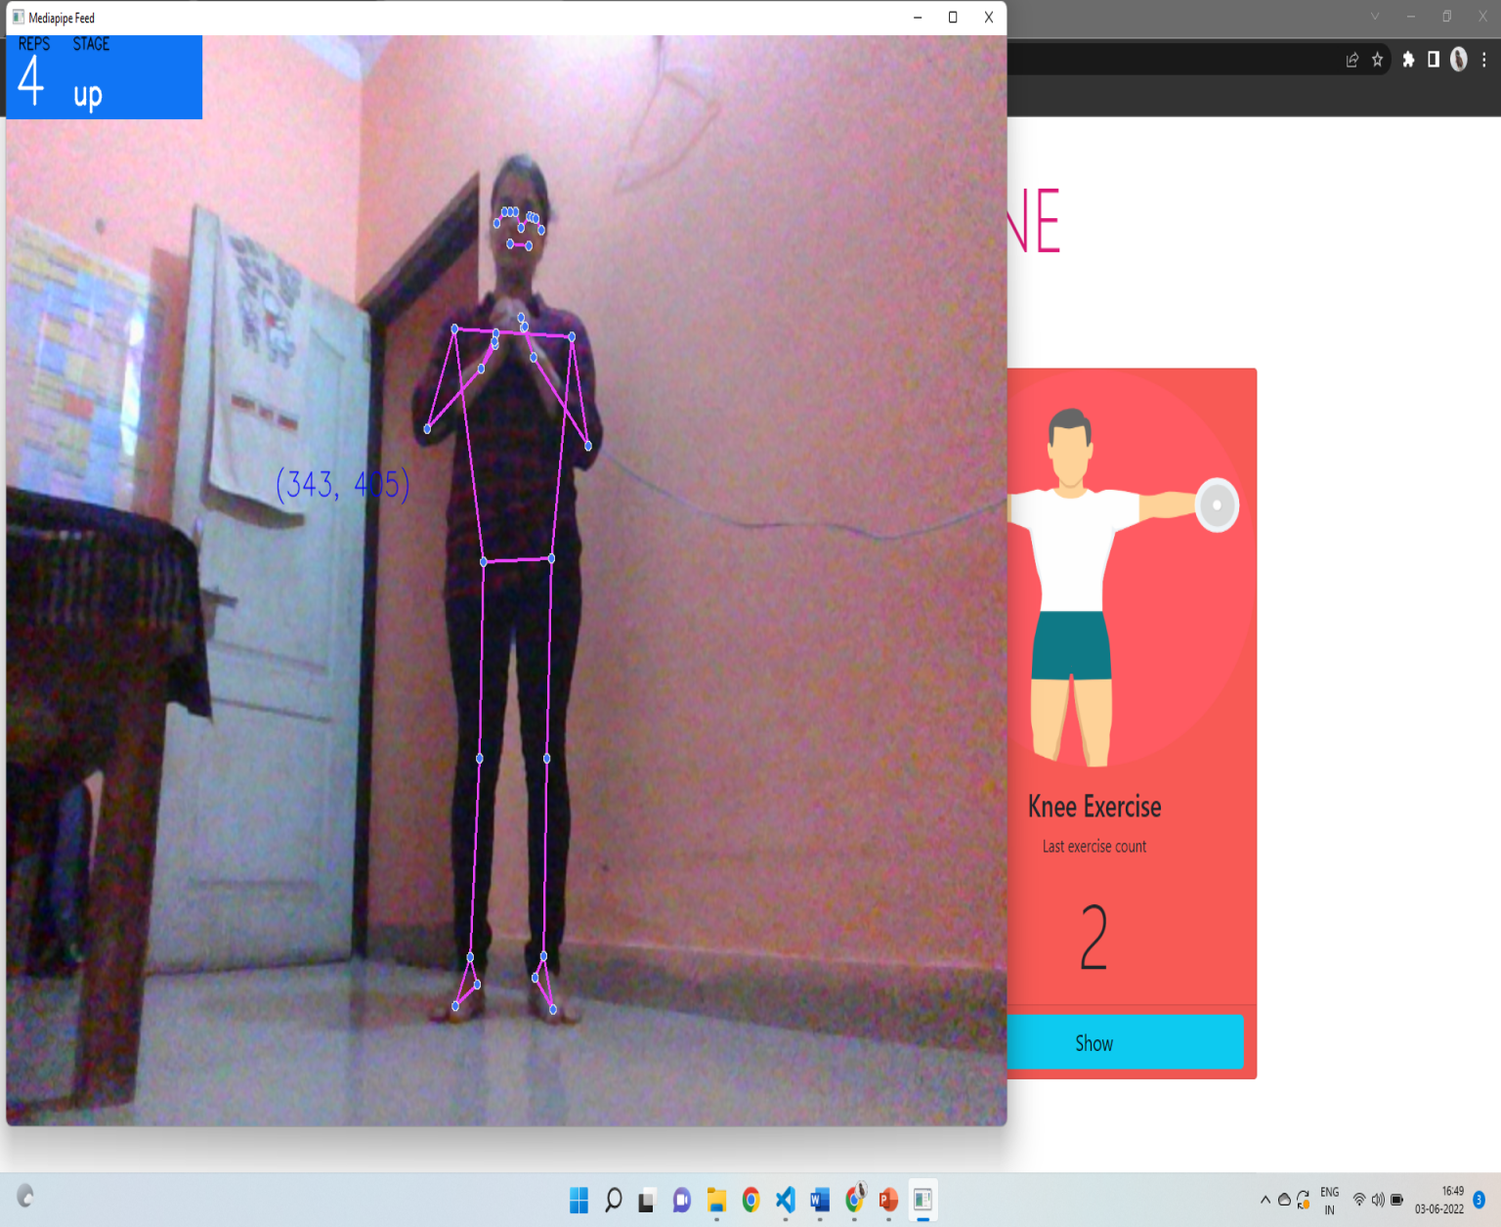

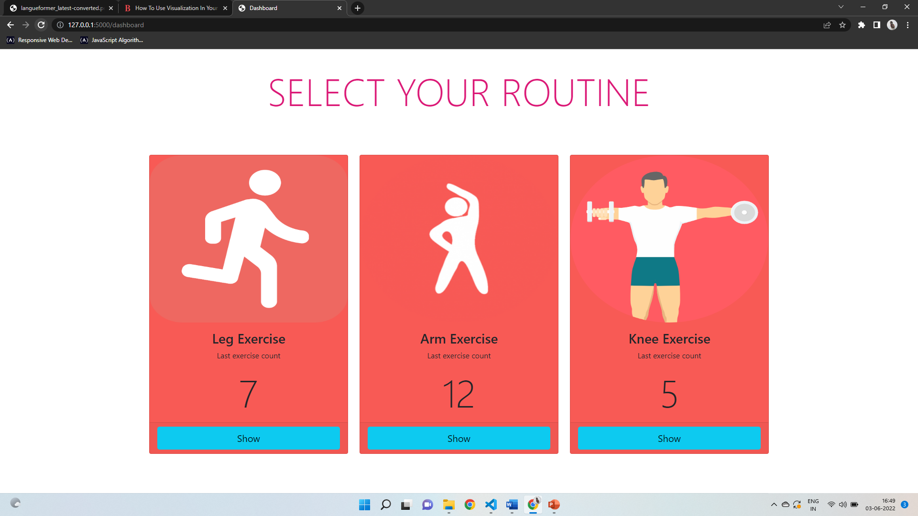

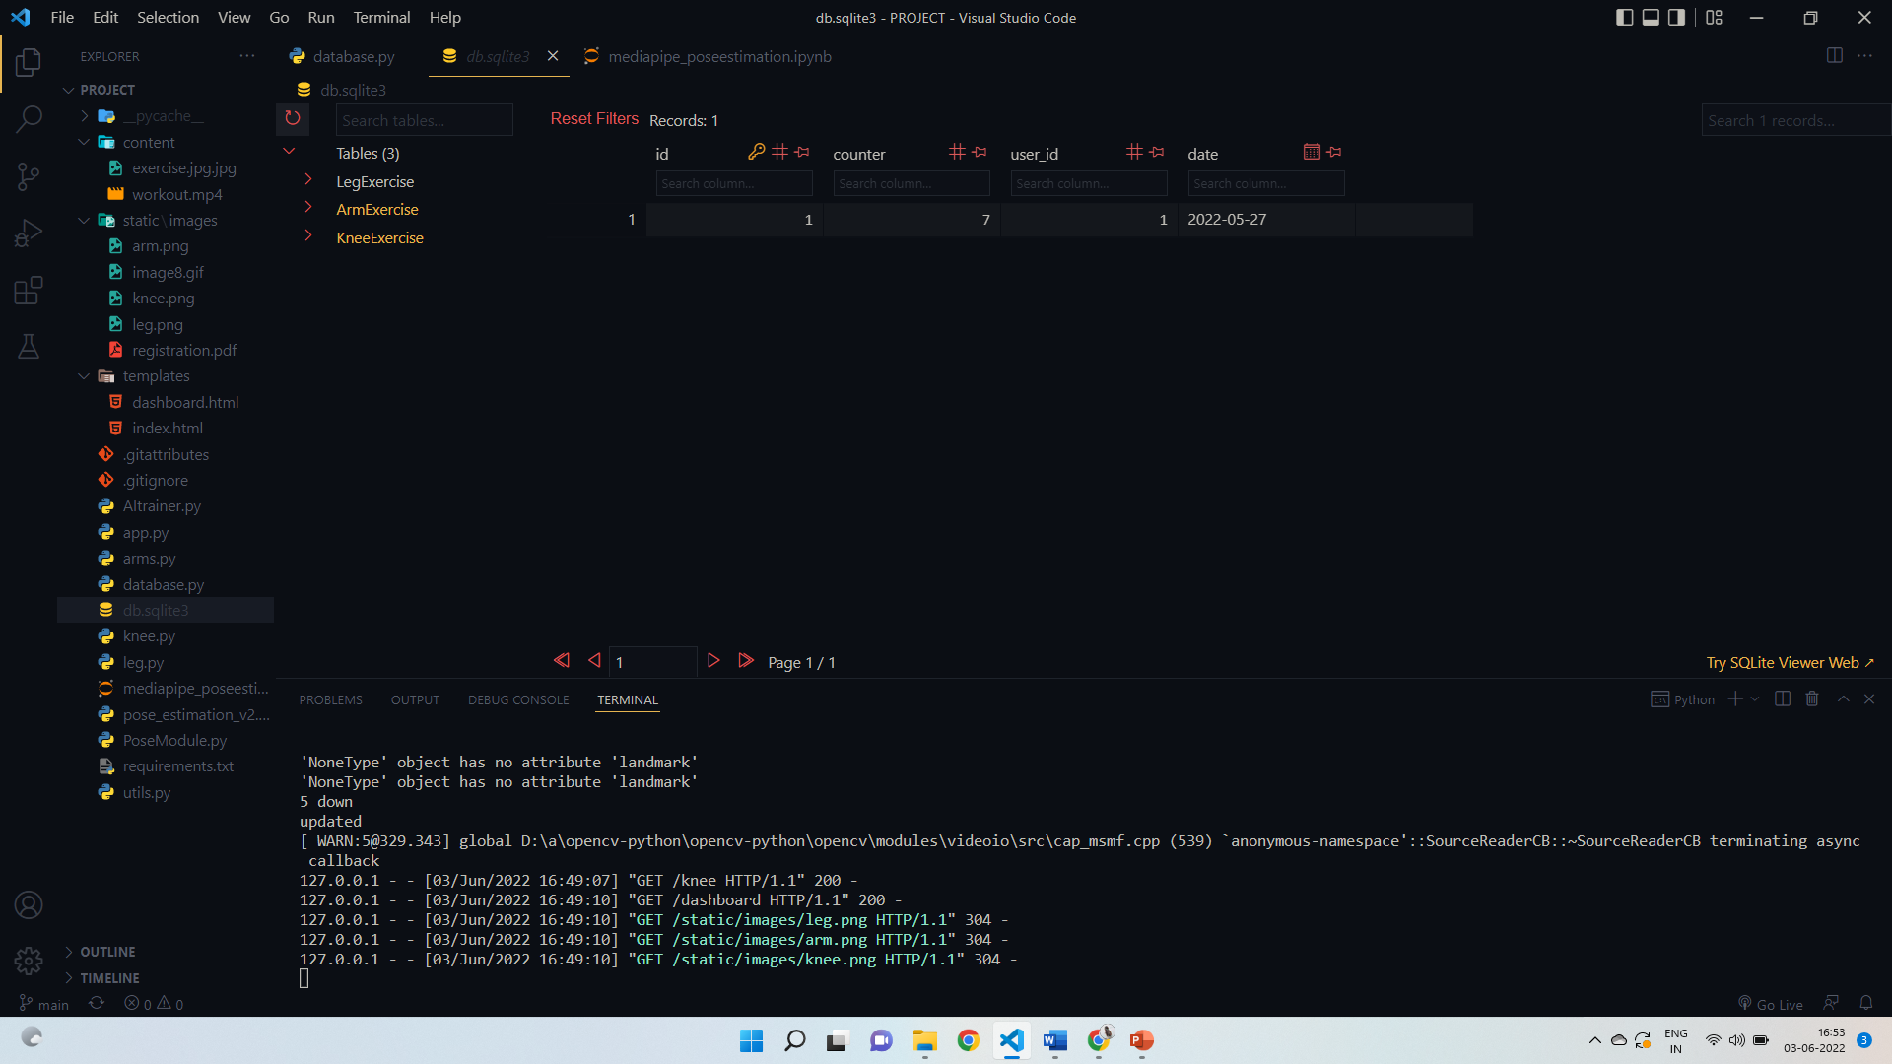

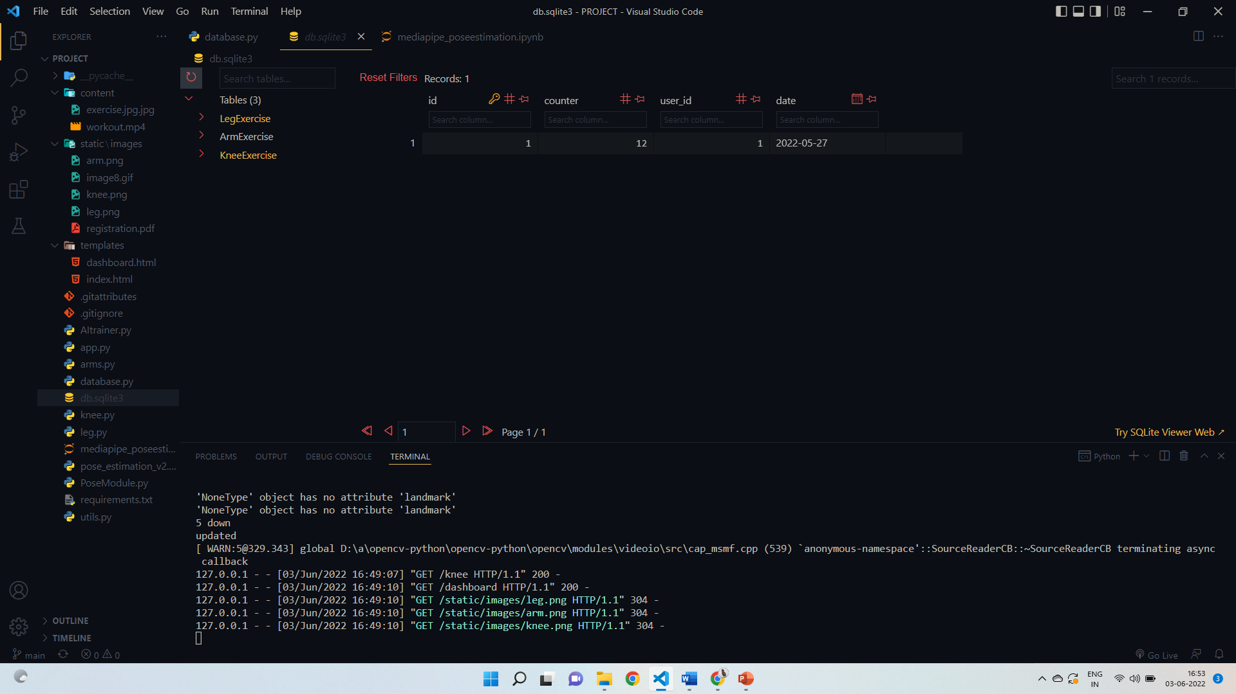

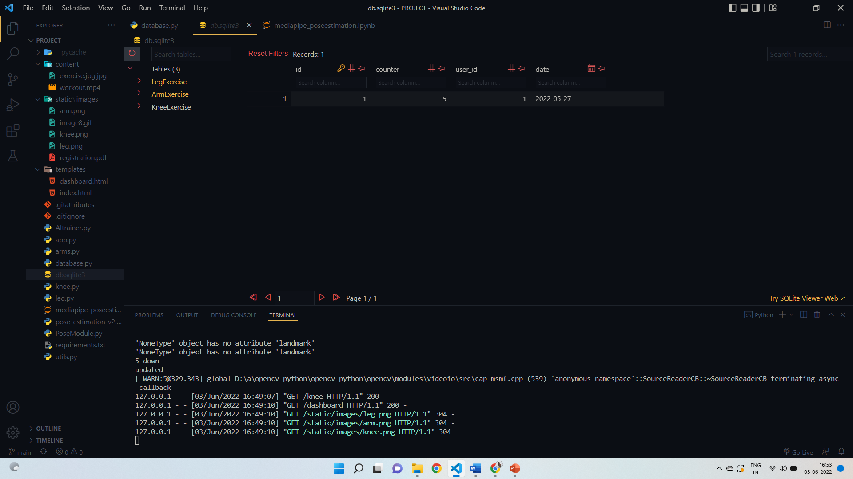

**FUTURE SCOPE**

* + Easy accessibility of exercise-Personal gym trainer an AI based provide us easy accessibility of exercise and various type of mode for performing the physical activity easily without any cost and time.
  + Reduce the risk of health –related problem-by doing regular exercise the health –related issues get-out and the vibrant energy comes in the body which make the wide and physique heathier.
  + Others:1-Easy to takle, where you want you can do the exercise.

2-With the help of this type of technology

people survive without the risk of any diseases.

# CONCLUSION

* **As our lives are getting busier , we hardly find time to exercise regularly . That’s why you can even seen increased health issues, such as cancer diabetes , and more.**
* **However , AI in fitness is trying to solve this problem.**
* **Hence artificial intelligence based personal gym training was an awesome platform for maintaining our body as well as our wealth also.**

# CHALLENGES AND LIMITATIONS

#### CHALLENGES:

1. Initially the project was developing using the system in which SSD was not installed so model was taking a lot of time to load.
2. Failure of model file when project was in last stage.

#### LIMITATIONS:

1. It is connection-oriented web application.
2. System without graphics cards will take a little more time to load the model.

# BIBLIOGRAPHY

I have taken information of this project by using some of the websites given below:

1. [https://www.python.org](https://www.python.org/)
2. [https://streamlit.io](https://streamlit.io/)
3. <https://opencv.co>
4. <https://mediapipe.org>
5. https://sqlalchemy.org

# GLOSSARY

**Annotations:** It is a highlighted word or sentence giving information about it using different colours.

**Inference:** These are the settings for customization with respect to graphics card of a system.

**Max Candidates:** It is used for sentence rephrasing in Grammar Corrector/Highlighter Model.

**Quality Filter:** It ensures that quality of sentence should not be degrading in terms of punctuations.

**Text Polishing:** It is a degree by which sentences can be polished without changing their actual meaning.